Span of Control



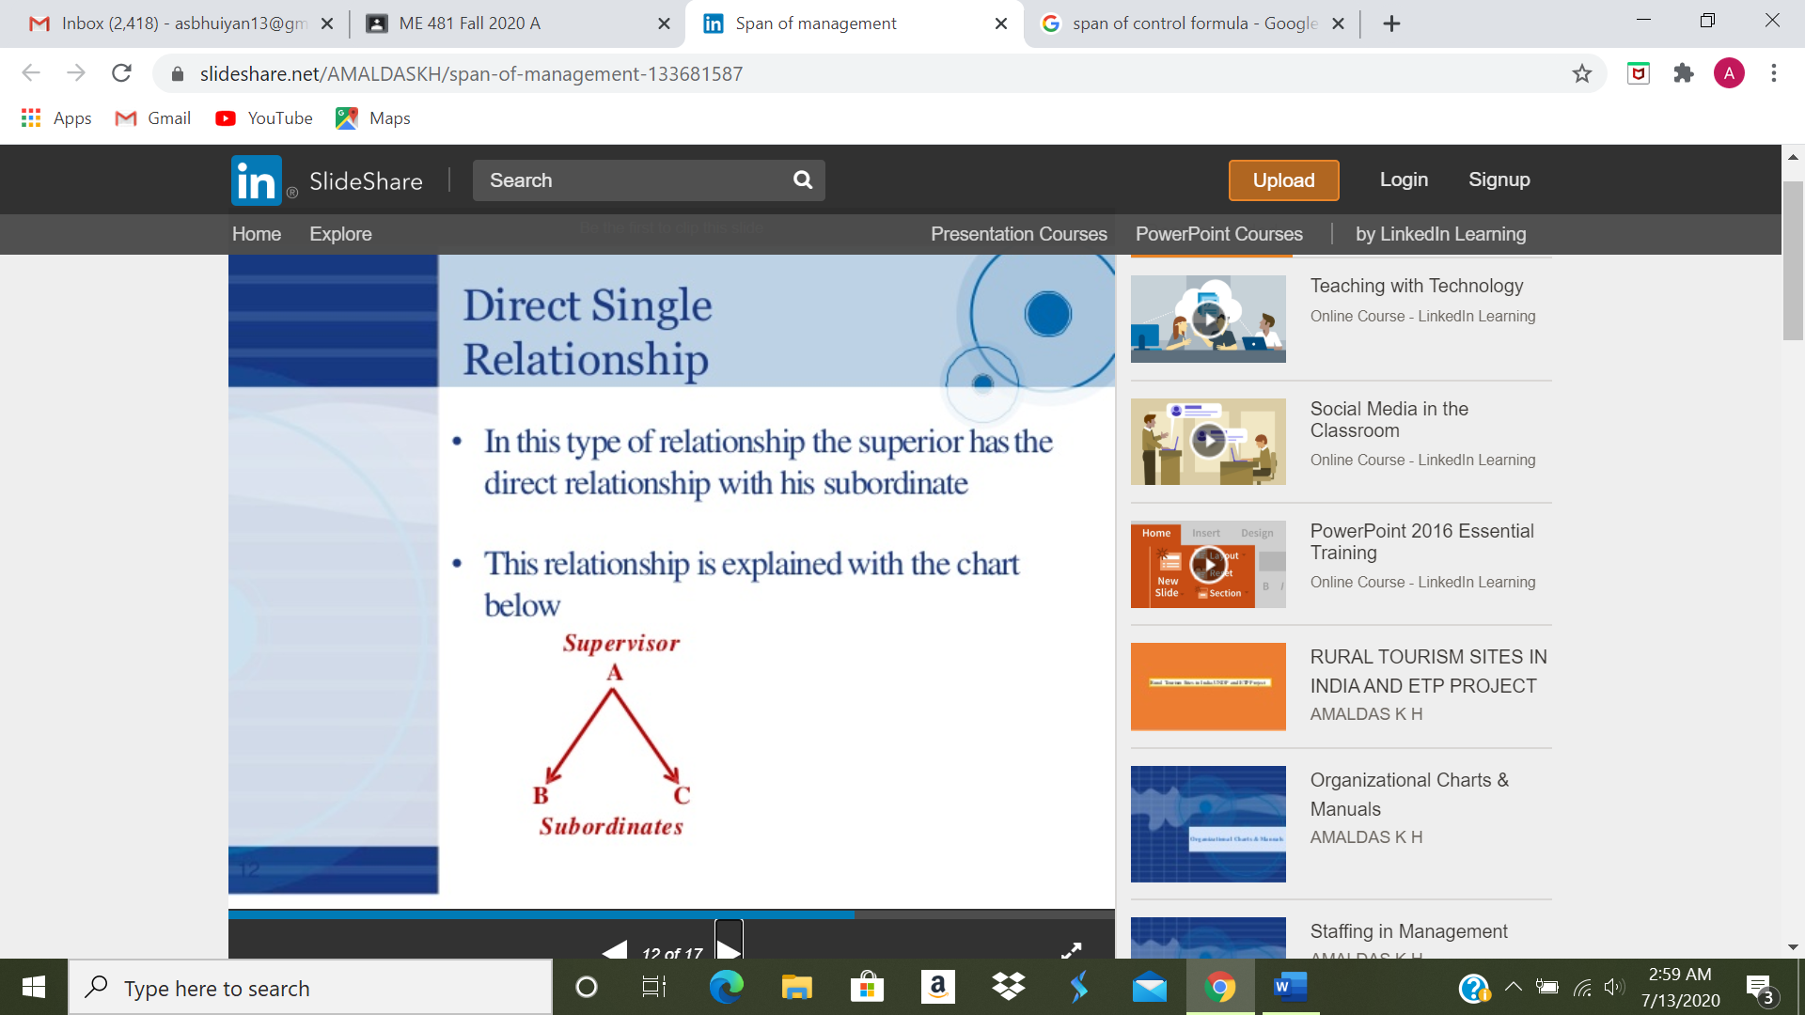

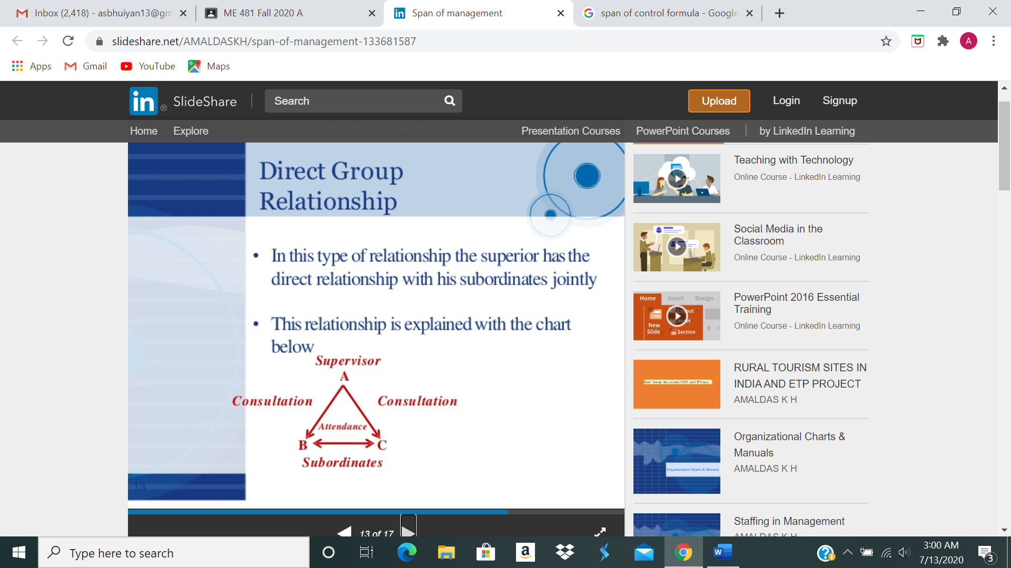

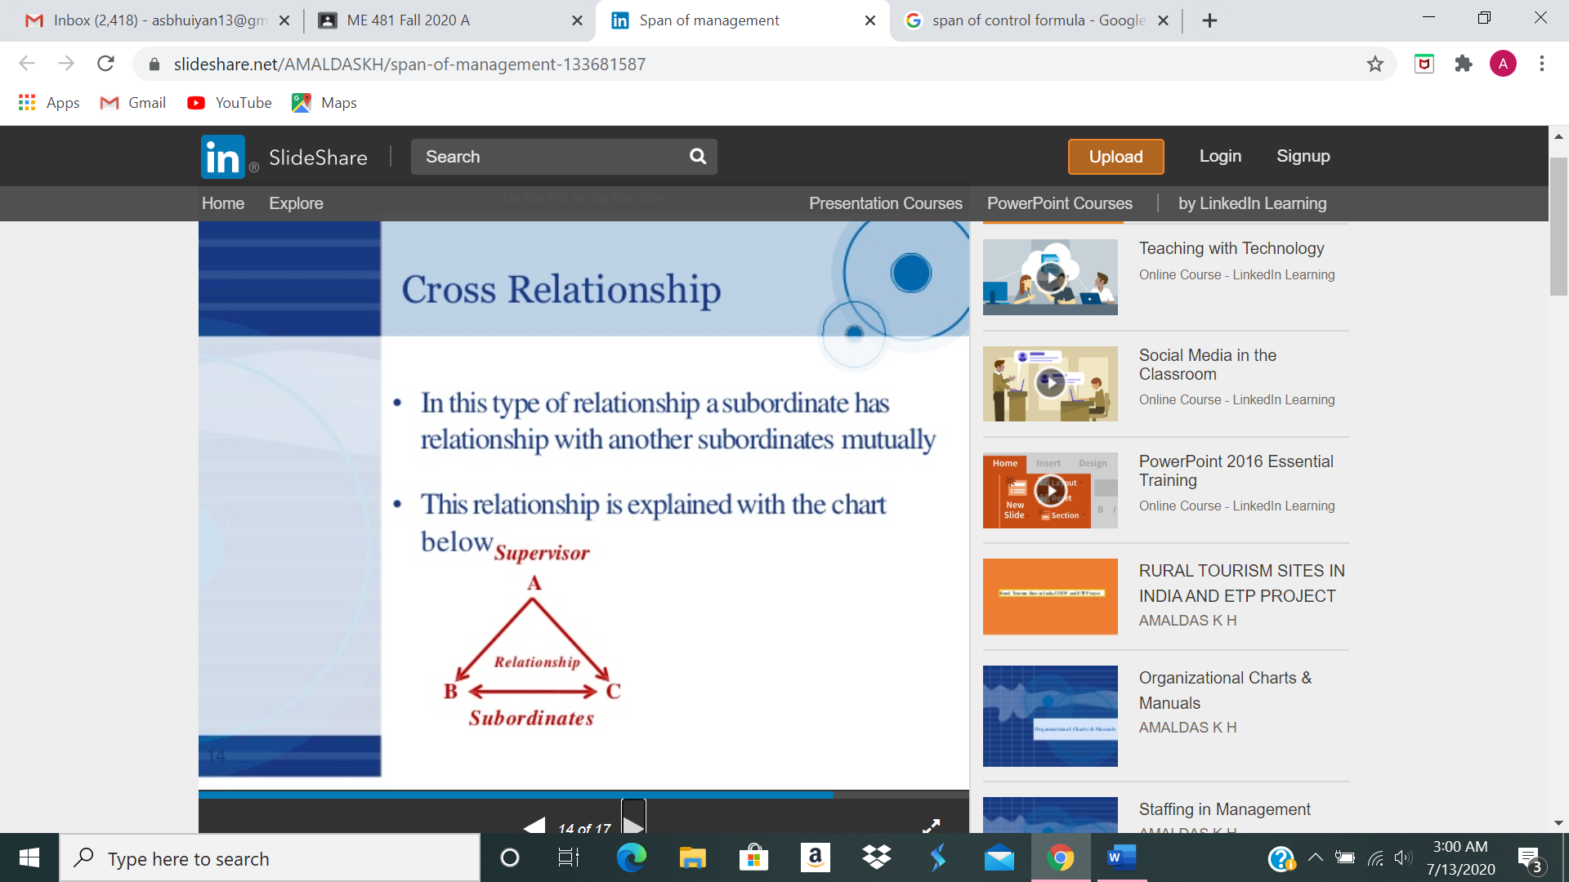

Span of Control: The Formulas of V. A. Graicunas

© Fred Nickols 2012

Note: For a downloadable, PDF version of this paper, click here.

The span of control is a perennial topic in discussions of management. In January of 1998, I had occasion to post to an HR list a comment about span of control and the formulas of V. A. Graicunas. Almost two years later, that posting led to a request for those formulas. I honored that request and then it occurred to me that others might be interested, too, and so I've put up this page on my web site. First, however, a little history.

V. A. Graicunas

Vytautus. A. Graicunas was a Paris-based management consultant. His seminal paper was first published in the March 1933 issue of The Bulletin of the International Management Institute and was reprinted in 1937 in Papers on the Science of Administration. That classic in the management literature was edited by Luther Gulick and Lyndall F. Urwick. In 1956, in the May-June issue of the Harvard Business Review, Urwick published an article titled "The Manager's Span of Control," in which he mentions helping Graicunas formulate the 1933 paper. Urwick also notes that Graicunas, a native-born Lithuanian, disappeared in the aftermath of the Russian occupation of Lithuania and was presumed dead at that time. Graicunas did in fact survive the war but was arrested by the Russians in 1947 and died in a Russian prison. There is an interesting biographical note here.

Limiting the Span of Control

The issue Graicunas addressed in his paper was the lack of a theoretical basis for the empirical belief in limiting the span of control. Graicunas thought the theoretical evidence in favor of limiting the span of control was overwhelming. For one thing, he cited the limited span of attention, which was then exemplified by research suggesting people could deal with no more than six digits. Graicunas also pointed to what he saw as an error in thinking, namely, that the relationships to be managed consisted only of those between the superior and individual subordinates. But, as he pointed out, there were relationships between subordinates and between the superior and groups of subordinates that had to be factored in to the equation.

Graicunas summed up the prevailing view of the reason for limiting the span of control in these words: "[O]ne of the surest sources of delay and confusion is to allow any superior to be directly responsible for the control of too many subordinates." Urwick put it a little stronger, writing as follows:

"There is nothing which rots morale more quickly and more completely than poor communication and indecisiveness -- the feeling that those in authority do not know their own minds. And there is no condition which more quickly produces a sense of indecision among subordinates or more effectively hampers communication than being responsible to a superior who has too wide a span of control (p.43)."

Graicunas and, later, Urwick, both noted the existence of pressures to increase the span of control. First, of course, is the tendency of people to want to report directly to the boss, whomever that might be. Second, is the tendency to build empires. Third is the pressure to reduce the costs of management overhead. Fourth is a commendable desire to shorten the chain of command. Fifth, extending the span of control necessarily flattens the organization and drives authority and responsibility downward, both of which are favorites of those who would democratize an organization. Sixth, the existence in seemingly well-run organizations of spans of control larger than the five or six recommended by Graicunas and Urwick invalidates the concept of limiting the span of control.

The main thrust of Urwick's article was to counter the arguments being made against limits on the span of control. In all cases, Urwick pointed out, the benefits of flattening the organization, forcing authority and initiative downward, and reducing the overhead costs of management had to be weighed against the costs of confusion and indecision that accompany a span of control that is too broad. Often, he claimed, the latter outweighed the former.

The fundamental question, of course, was and still is how many is too many? Graicunas and Urwick both cited General Sir Ian Hamilton, who, in 1922, wrote the following:

"The nearer we approach the supreme head of the whole organization, the more we ought to work towards groups of three; the closer we get to the foot of the whole organization, the more we work towards groups of six."

The Soul and Body of an Army

Arnold, London, 1922, p.229

Graicunas himself suggested that the maximum number of subordinates should be five and probably four in most cases. These figures were tempered with considerations of the scope and scale of the work involved and for which the subordinate was responsible. For example, a group of six factory workers reporting to a supervisor presents a less complex problem than six division presidents reporting to the CEO of a large company. And six presidents of completely independent divisions presents a simpler problem than six vice presidents of closely integrated divisions. Regardless of these considerations, the number of relationships a superior must attend to rises exponentially after the fourth subordinate. Thus Graicunas cautioned any executive seeking to add a fifth directly reporting subordinate to consider the fact that this would add 20 new relationships for himself and nine for each of his current colleagues. The total number of relationships would increase by 56, going from 44 to 100. As Graicunas noted, this was "an increase in complexity of 127 per cent in return for a 20 per cent increase in working capacity."

Graicunas' paper contains formulas, a table and a chart, all showing the exponential growth in complexity of relationships as the number of reporting subordinates increases. Three basic kinds of relationships were described.

* Direct single relationships between superior and individual subordinates.
* Cross relationships between individual subordinates.
* Direct group relationships between superior and combinations of subordinates.

The relevant notations and elements are provided below and subsequently illustrated using Graicunas' example of a superior, Tom, who has two subordinates, Dick and Harry.

* n = number of persons supervised
* a = number of direct single relationships (superior to subordinate)
* b = number of cross relationships (subordinate to subordinate - in both directions)
* c = number of direct group relationships (superior to combinations of subordinates)
* d = total group relationships (a + b)
* e = total of direct relationships (a + c)
* f = total of direct and group relationships (a + b + c)

Regarding b above, it is worth noting that Dick's relationship with Harry differs from Harry's relationship with Dick. Hence, there are really two relationships between two subordinates, not one.

Regarding c above, Tom's relationship with Dick is different when Harry is present just as Tom's relationship with Harry is different when Dick is present.

**Example (Tom, Dick and Harry)**

* n = 2 (Dick and Harry)
* a = 2 (Tom to Dick and Tom to Harry)
* b = 2 (Dick to Harry and Harry to Dick)
* c = 2 (Tom to Dick, with Harry present; and Tom to Harry, with Dick present)
* d = 4 (a + b)
* e = 4 (a + c)
* f = 6 (a + b + c)

Graicunas went on from this very simple case to create a table depicting the number of relationships for up to 12 subordinates. A chart based on the table demonstrates that, as the number of subordinates increases past four, the complexity of the relationships increases exponentially. This owes primarily to an increase in the number of direct group relationships created by adding a member to an existing group. For example, as noted above, adding a fifth subordinate roughly doubles complexity, increasing the total direct plus cross relationships from 44 to 100. Adding a sixth subordinate more than doubles complexity again, increasing the number of relationships from about 100 to 222. For 12 subordinates, the total number of relationships that might demand a superior's attention is an astounding 24,564.

The figures just mentioned are derived from Graicunas' table which was apparently calculated using the formulas he provided. He provided two sets of formulas, one for situations in which relationships between two subordinates are counted once and one for situations in which they are counted twice. He referred to the first situation as "maximum" and the second as "minimum" and provided formulas for both situations. The figures from the table cited above were for the maximum case. However, in both cases, the number of relationships rises exponentially.

**Maximum Case**

**(Subordinates are responsible for interdependent work or units)**

Kind of Relationship Variable Formula

* Direct single relationships a n
* Cross relationships b n (n – 1)
* Direct group relationships c n (2n/2 – 1)
* Total direct single and cross relationships (a + b) d n2
* Total direct single and group (a + c) e n (2n/2)
* Total direct and cross relationships (a + b + c) f n (2n/2 + n – 1)

**Minimum Case**

**(Subordinates are responsible for independent work or units)**

Kind of Relationship Variable Formula

* Direct single relationships a n
* Cross relationships b' n/2 (n – 1)
* Direct group relationships c' 2n – n – 1
* Total direct single and cross relationships (a + b') d' n/2 (n + 1)
* Total direct single and group (a + c') e' 2n – 1
* Total direct and cross relationships (a + b' + c') f' 2n + n/2 (n – 1) – 1

So, how many is too many when it comes to subordinates? There is no hard answer. The situation seems to be pretty much the same as it was when Graicunas and Urwick were making their arguments. In short, it's a judgment call, one that is affected by factors such as the abilities and style of the superior, the scope and scale of the work assigned to the individual subordinates, and the amount and nature of interaction that work requires between and among subordinates and the superior. And, although neither Graicunas or Urwick mentioned it specifically, organizations must be governed as well as managed, led and administered. This requirement necessitates achieving and maintaining some balance of power. Often this is accomplished through reporting relationships and the control over resources they bring with them.

References

Graicunas, V.A., "Relationship in Organization (pp. 183-187) in Papers on the Science of Administration, edited by Luther Gulick and Lyndal F. Urwick, published by Columbia University's Institute of Public Adminstration in 1937.

Urwick, L. F., "The Manager's Span of Control" (pp. 39-47) in the May-June 1956 issue of the Harvard Business Review.